Problem Specification/Project Plan
(Page limit: 5 pages maximum)
Project Title: Practical Benchmarking of Approximate Machine Unlearning for Auditable Enterprise ML Erasure Workflows (Can I change this throughout?)
Student Name: Niamh Hughes
Student ID: 40299386
Project Supervisor Name: Awais Rauf

- Introduction
  - Project Overview
This project will investigate the effectiveness of machine unlearning techniques as alternatives to full model retraining. The study will compare Full retraining, Retain-set fine-tuning, gradient ascent unlearning and SISA across different tabular classification datasets. Each method will be evaluated in terms of predictive performance, privacy preservation, similarity to a retrained baseline and computational efficiency. The project will aim to compare these and assess their suitability for supporting data deletion requirement in real-life scenarios.
1.2 Objectives
To investigate existing machine unlearning techniques and their role in supporting data deletion requirements within machine learning systems.
To implement and evaluate Full Retraining, Retain-Set Fine-Tuning, Gradient Ascent Unlearning and SISA on tabular classification models.
To assess the impact of each unlearning method on predictive performance using AUROC and F1 Score.
To evaluate the similarity of unlearned models to a fully retrained baseline using prediction agreement.
To assess the effectiveness of each method in reducing privacy leakage through Membership Inference Attacks (MIA).
To compare the computational efficiency of machine unlearning methods against full model retraining.
To analyse the trade-offs between utility, privacy preservation and computational cost across multiple datasets.

- Problem Specification
2.1 Background and Context
As more sectors begin using machine learning, the amount of users personal data that is being stored increases. This can raise concerns surrounding privacy and data protection of user data, and GDPR have reacted to this, introducing stricter requirements regarding the collection, retention and deletion of personal information. Article 17 of the GDPR establishes the Right of Erasure, allowing individuals to request the deletion of their personal data under certain circumstances[19]. Additionally, organisations are required to comply with data retention principles ensuring that personal data is not stored for longer than deemed necessary. While the data can be removed, its influence may still be embedded within machine learning models, and data may be inferred from this. As a result, methods to unlearn this have emerged to find faster ways than fully retraining large models.
2.2 Problem Domain
The key challenge surrounds the idea that removing a record from a dataset does not remove its learned influence from the model. Full retraining can be computationally expensive and inefficient for large datasets. Approximate methods offer alternatives, but there may be trade-offs with different methods between forgetting effectiveness, predictive performance and runtime. Another challenge is verifying whether unlearning has occurred as model accuracy alone does not prove it. Therefore, we will compare different methods using measurable criteria such as AUROC, F1 score, prediction agreement with a retrained baseline, membership inference attack performance and computational efficiency.

- Research Methods and AI Algorithms
An experimental research approach will be adopted to evaluate the machine unlearning techniques. Three publicly available tabular classification datasets will be used: Adult Income, Bank Marketing and Hotel Booking Demand. The datasets will be pre-processed using standard ML techniques and analysed using a MLP (why). Artificial data deletion requests will be simulated using 2 methods; removing a small selection who ‘opted out’ and adding a new simulated column ‘date captured’ after some time, records will be auto removed.
The study will compare Full retraining, retain-set fine-tuning, gradient ascent unlearning and SISA. Full retraining will serve as the Vaseline against which the other methods will be evaluated. Performance will be assessed using AUROC, F1 score, Prediction agreement with retrained baseline, membership inference attacks (MIA) and runtime measurements. These techniques have been chosen to evaluate the trade-offs between predictive performance, privacy preservation and computational efficiency.
- Anticipated Results
The project is expected to provide a comparative evaluation of machine unlearning techniques and their effectiveness as alternatives to full model retraining. Retain-set fine-tuning is expected to offer the greatest efficiency gains, although it may provide the weakest forgetting performance due to the continued influence of deleted records within the model. Gradient ascent unlearning is expected to achieve stronger forgetting than fine-tuning but may be at the expense of predictive performance. SISA is expected to provide the most balanced approach as it is specifically designed to support efficient data deletion and unlearning. The identification of these trade-offs may provide insights into their suitability for supporting data deletion requirements in real-world machine learning systems.

- Project Plan and Timeline
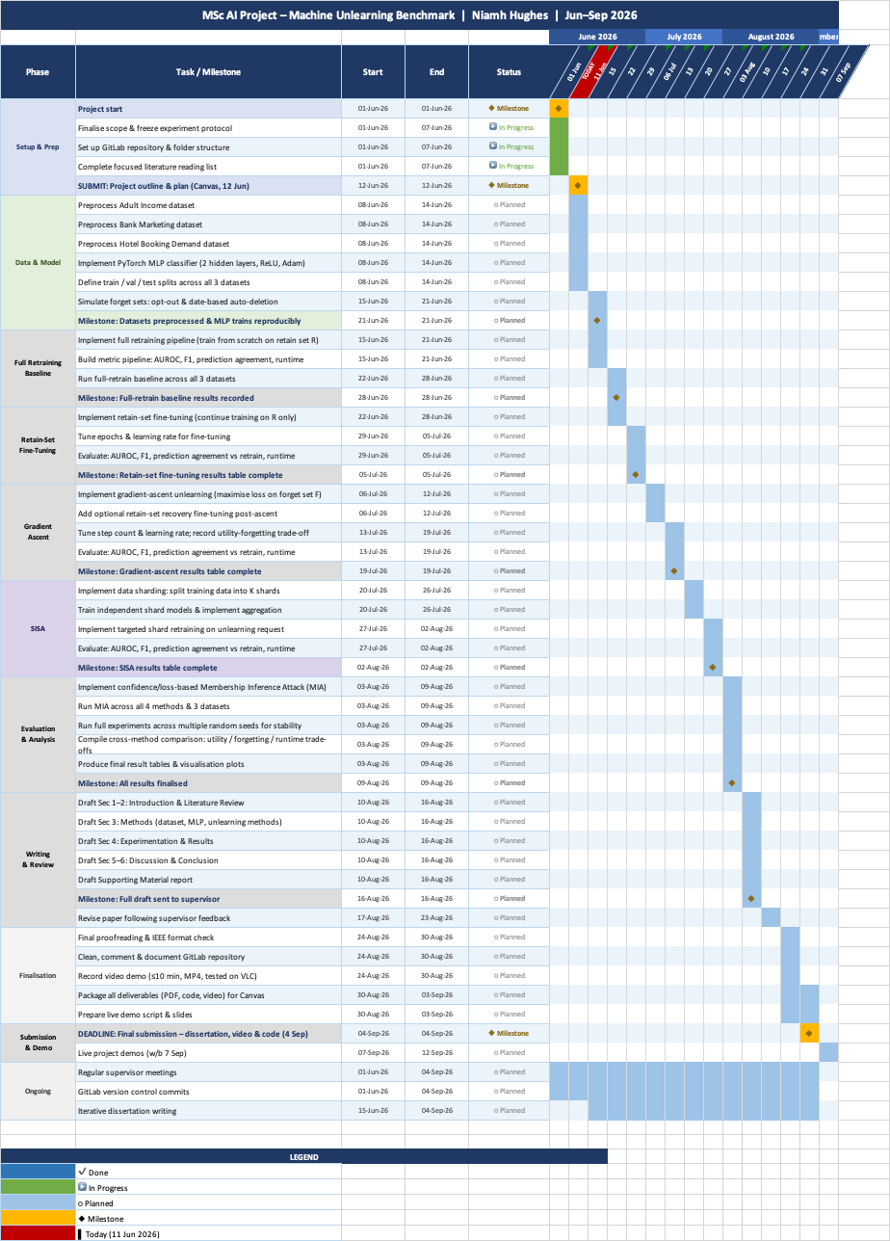

- Hardware and Software Resources to be used within the project:
Hardware Resources
- Minimum 16GB RAM and multi-core CPU for data processing and model training.
- Access to Microsoft Azure through ISx4.
- Ability to provision Azure Virtual Machines (VMs) with GPU acceleration if additional computational resources are required.
- Access to university computing facilities as a secondary contingency option.
Software Resources
- PyTorch for implementation of the MLP model and machine unlearning techniques.
- Scikit-learn for preprocessing, model evaluation and performance metrics.
- Pandas and NumPy for data manipulation and analysis.
- Matplotlib and Seaborn for data visualisation.
- Visual Studio Code and Jupyter Notebooks for development and experimentation.
- Git and GitHub for version control and project management.
Data Resources
- Adult Income Dataset (UCI Machine Learning Repository).
- Bank Marketing Dataset (UCI Machine Learning Repository).
- Hotel Booking Demand Dataset (UCI Machine Learning Repository).
All datasets and software tools required for the project are publicly available or accessible through existing university and workplace resources.

- Risk Management
Implementation Complexity of SISA
- Unlike the other selected methods, SISA requires data sharding, independent model training and prediction aggregation. This introduces additional implementation complexity and may increase development time.
- Mitigation: Full Retraining, Retain-Set Fine-Tuning and Gradient Ascent Unlearning will be implemented and validated before SISA. The implementation will closely follow the methodology proposed by Bourtoule et al.[4] with the number of shards and slices kept deliberately small to reduce experimental complexity while maintaining the core principles of the approach.
Verifying Whether Unlearning Has Actually Occurred
- A key challenge within the machine unlearning literature is determining whether a model has genuinely forgotten deleted records. Strong predictive performance alone does not demonstrate successful unlearning, as models may continue to retain or leak information about removed data despite maintaining similar accuracy.
- Mitigation: Multiple evaluation metrics will be used, including AUROC, F1 Score, Prediction Agreement with a Retrained Baseline and Membership Inference Attacks (MIA), providing a more comprehensive assessment of unlearning effectiveness.
Limited Observable Benefits of SISA
- SISA was developed to reduce the cost of unlearning in large-scale machine learning systems where full retraining is computationally expensive. The datasets and model architecture used in this project are comparatively lightweight, which may reduce the observable efficiency benefits reported in the literature.
- Mitigation: SISA will be evaluated across multiple datasets and compared against Full Retraining, Retain-Set Fine-Tuning and Gradient Ascent Unlearning using both performance and runtime metrics. Findings will be interpreted within the context of the selected datasets and model architecture.
Computational Resource Requirements
- The project requires repeated training, retraining and unlearning experiments across multiple datasets and evaluation scenarios. The cumulative computational cost may exceed the practical capabilities of local hardware, particularly when conducting extensive comparative evaluations.
- Mitigation: Access to Microsoft Azure through ISx4 provides the ability to provision virtual machines with GPU acceleration if required. Experiments will initially be conducted on local hardware, with cloud-based resources utilised where additional computational capacity is needed.

- References (Use IEEE Style):
[1] Y. Cao and J. Yang, "Towards Making Systems Forget with Machine Unlearning," in 2015 IEEE Symposium on Security and Privacy (SP), San Jose, CA, USA, 2015, pp. 463–480.
[2] A. Ginart, M. Y. Guan, G. Valiant and J. Zou, "Making AI Forget You: Data Deletion in Machine Learning," in Advances in Neural Information Processing Systems (NeurIPS 2019), vol. 32, 2019, pp. 3513–3526.
[3] A. Golatkar, A. Achille and S. Soatto, "Eternal Sunshine of the Spotless Net: Selective Forgetting in Deep Networks," in Proceedings of the IEEE/CVF Conference on Computer Vision and Pattern Recognition (CVPR), 2020, pp. 9304–9312.
[4] L. Bourtoule, V. Chandrasekaran, C. A. Choquette-Choo, H. Jia, A. Travers, B. Zhang, D. Lie and N. Papernot, "Machine Unlearning," in 2021 IEEE Symposium on Security and Privacy (SP), 2021, pp. 141–159.
[5] S. Neel, A. Roth and S. Sharifi-Malvajerdi, "Descent-to-Delete: Gradient-Based Methods for Machine Unlearning," in Algorithmic Learning Theory (ALT), 2021.
[6] A. Golatkar, A. Achille, A. Ravichandran and S. Soatto, "Mixed-Privacy Forgetting in Deep Networks," arXiv preprint arXiv:2003.10933, 2021.
[7] J. Xu, Y. Wang, Y. Wang et al., "Machine Unlearning: A Survey," ACM Computing Surveys, 2024.
[8] X. F. Cadet, A. Borovykh, M. Malekzadeh, S. Ahmadi-Abhari and H. Haddadi, "Deep Unlearn: Benchmarking Machine Unlearning," arXiv preprint arXiv:2405.09355, 2024.
[9] R. Shokri, M. Stronati, C. Song and V. Shmatikov, "Membership Inference Attacks Against Machine Learning Models," in 2017 IEEE Symposium on Security and Privacy (SP), 2017, pp. 3–18.
[10] N. Carlini, S. Chien, M. Nasr, S. Song, A. Terzis and F. Tramèr, "Membership Inference Attacks From First Principles," in 2022 IEEE Symposium on Security and Privacy (SP), 2022, pp. 1897–1914.
[11] R. Eldan and M. Russinovich, "Who's Harry Potter? Approximate Unlearning in LLMs," arXiv preprint arXiv:2310.02238, 2023.
[12] P. Maini, M. Yaghini, N. Papernot et al., "TOFU: A Task of Fictitious Unlearning for LLMs," arXiv preprint, 2024.
[13] R. Kohavi, "Scaling Up the Accuracy of Naive-Bayes Classifiers: A Decision-Tree Hybrid," in Proceedings of the Second International Conference on Knowledge Discovery and Data Mining (KDD-96), 1996, pp. 202–207.
[14] B. Becker and R. Kohavi, Adult Data Set, UCI Machine Learning Repository, 1996.
[15] S. Moro, P. Cortez and P. Rita, "A Data-Driven Approach to Predict the Success of Bank Telemarketing," Decision Support Systems, vol. 62, pp. 22–31, 2014.
[16] S. Moro, R. Laureano and P. Cortez, Bank Marketing Data Set, UCI Machine Learning Repository, 2011.
[17] N. Antonio, A. de Almeida and L. Nunes, "Hotel Booking Demand Datasets," Data in Brief, vol. 22, pp. 41–49, 2019.
[18] N. Antonio, A. de Almeida and L. Nunes, Hotel Booking Demand Dataset, UCI Machine Learning Repository, 2019.
[19] UK Government, "Regulation (EU) 2016/679, Article 17: Right to Erasure ('Right to be Forgotten')," Legislation.gov.uk. [Online]. Available: https://www.legislation.gov.uk/eur/2016/679/article/17. [Accessed: 10-Jun-2026].
[20] Information Commissioner's Office (ICO), "Storage Limitation," ICO. [Online]. Available: https://ico.org.uk/for-organisations/uk-gdpr-guidance-and-resources/data-protection-principles/a-guide-to-the-data-protection-principles/storage-limitation/. [Accessed: 10-Jun-2026].

